I. Learning Summary

* In unit SIT325, I have some experience with Ubuntu on VM VirtualBox through simple interactions with the terminal like ran programs, edited files through nano and wrote some simple Python files.
* As I went through “Lab – Linux Basics”, I learned more about the nature of this OS by navigating through the GUI, interacting with files through the usage of Unix CLI or Terminal with introduced Linux commands – which are essential for me as I work on both fullstack development and cloud technologies as:
  + It provides a stable and flexible environment where I can develop, test, and deploy applications efficiently. Many tools and frameworks, such as Node.js, Python, and databases like MySQL and PostgreSQL, work best on Linux. Understanding Linux also helps me manage servers, automate deployments using command-line tools, and work with web servers like Apache and Nginx.
  + In cloud computing, Linux plays a major role since most cloud platforms like AWS, Google Cloud, and Azure rely on it for virtual machines and container management. Knowing Linux allows me to configure and maintain cloud-based applications, automate infrastructure tasks with shell scripting, and use tools like Ansible and Terraform. It also helps with system security, user management, and performance monitoring.
* Using Oracle VM VirtualBox adds another layer of practical learning by allowing me to run a Linux environment on my system without affecting my main operating system. It lets me safely practice Linux commands, experiment with new technologies like Docker and Kubernetes, and simulate cloud-based environments. This hands-on experience is valuable for improving my development and cloud management skills.

II. Lab Activities

Task 1 – Learn to navigate Ubuntu

I have started using VirtualBox VM since I studied for SIT 325 – Advanced Network Security as this was an important requirement to doing tasks.

Task 2 – Learn to navigate the CLI

/bin

/sbin

/usr/bin

/usr/sbin

I found that both /bin & /usr/bin are yielding the same display result, perhaps, “/usr” is used to pointing to files that are being shared among the users of this Ubuntu.

Task 3 – What does this do?

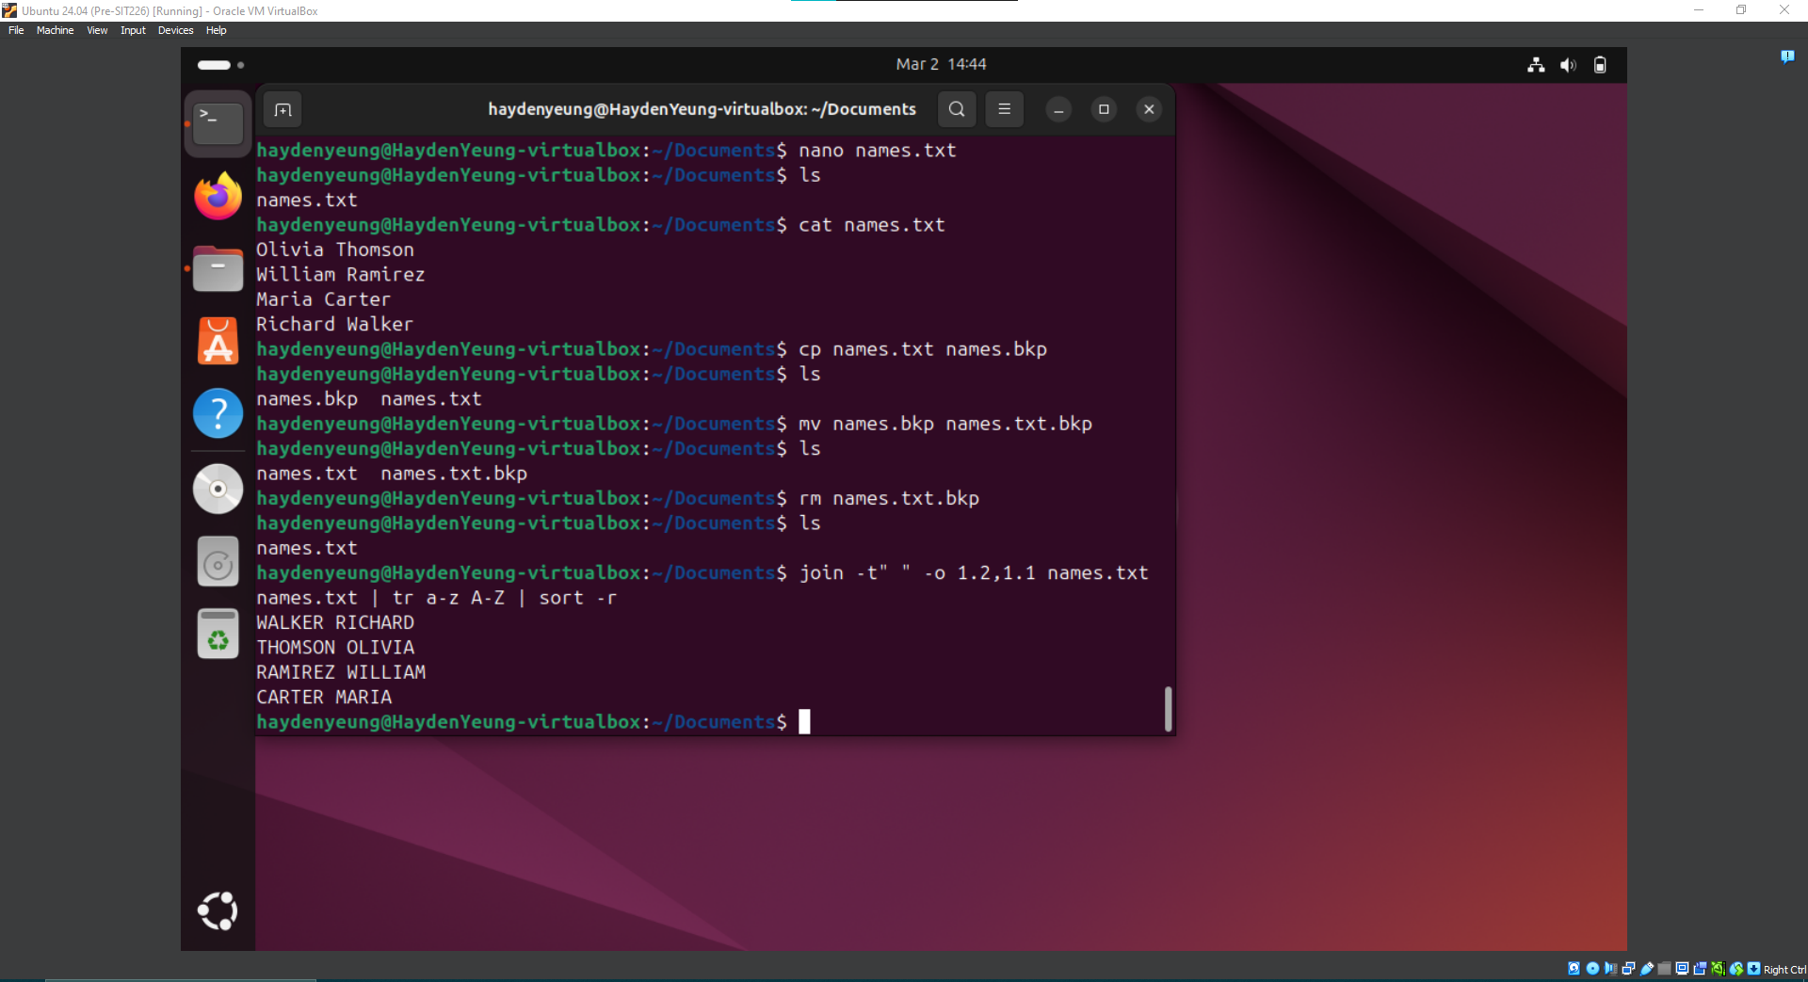

join -t” “ -o 1.2, 1.1 names.txt names.txt | tr a-z A-Z | sort -r

“join” - is a Linux command used for string concatenation between two files which are “names.txt” and itself.  
 -t” “ – is used to tell the computer that space between words in a line is the delimiter to separate two words in a line (e.g Olivia & Thomson) into 2 columns

1.2 - pick the 2nd column of the first “names.txt”

1.1 – pick the 1st column of the first "names.txt”

“tr a-z A-Z” – uppercase all the lower case letter of the chosen columns

“sort -r” – arrange display results in reverse alphabetic order.

Eventhough 1.2 & 1.1 are came from the first “names.txt” files but it is necessary to repeat “names.txt” twice for “join” command because of its nature requirement (2 text files)

Challenge Task 1. Learn the vi editor

I managed to complete the first part of this tutor and intent to continue it as I proceed through this unit.

Task 4 – Setting permissions with octal notation

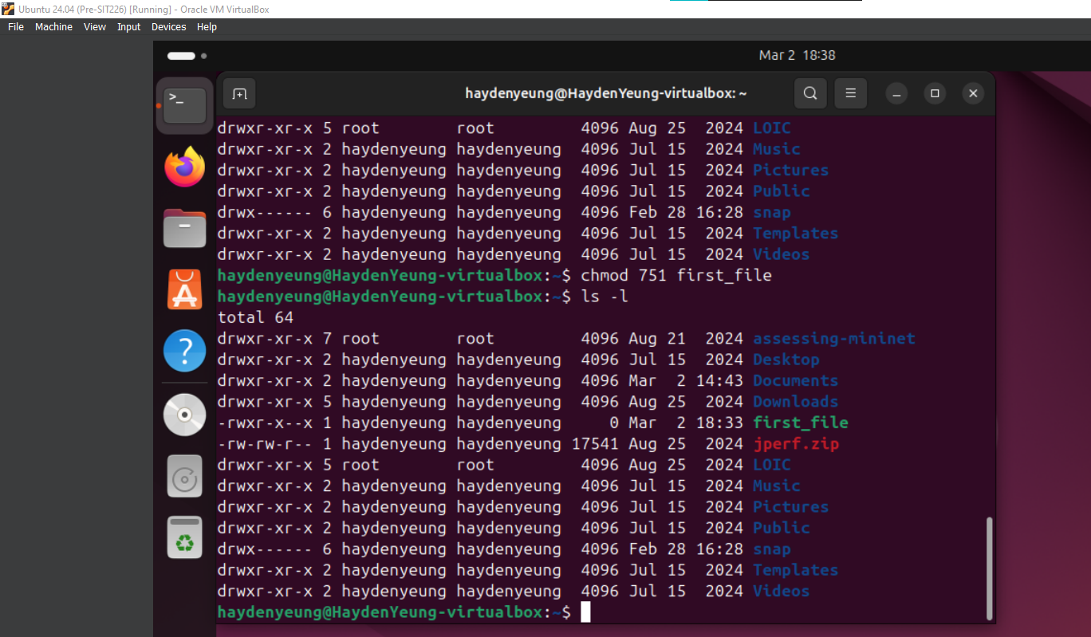

Explain: For user, 1 + 2 + 4 = 7 (execute + write + read – able)

For group, 1 + 4 = 5 (execute + read – able)

For other users, 1 (execute-able)

Task 5 – Setting permissions with symbolic notation

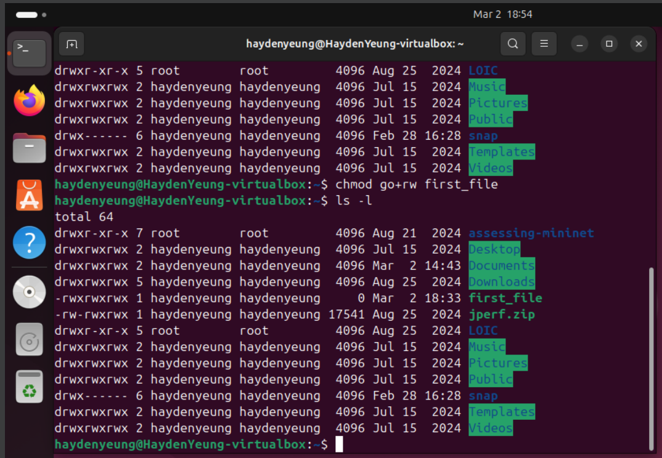

Since group and other users were missing of either read or write permissions so it is best to group these two together and add both read & write permissions to them regardless their current permissions.

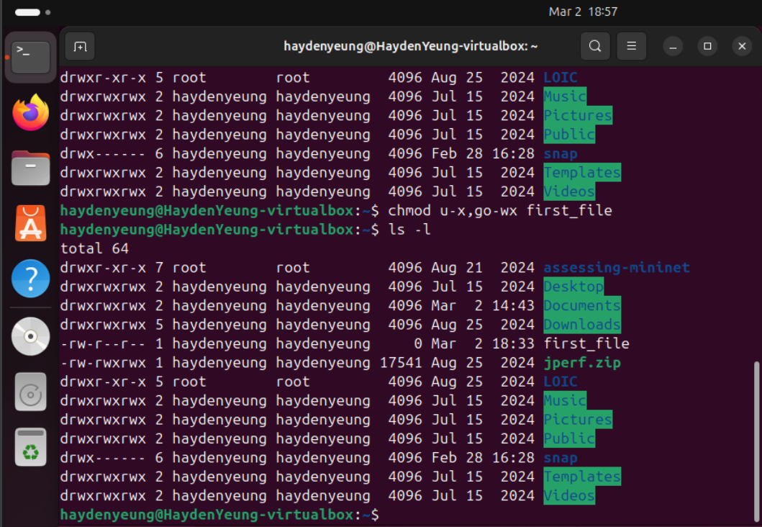

This is one of the method, the other one may be look like this: ugo-x, go-w

Or even as u-x, go=r

Challenge Task 2 – Putting it all together

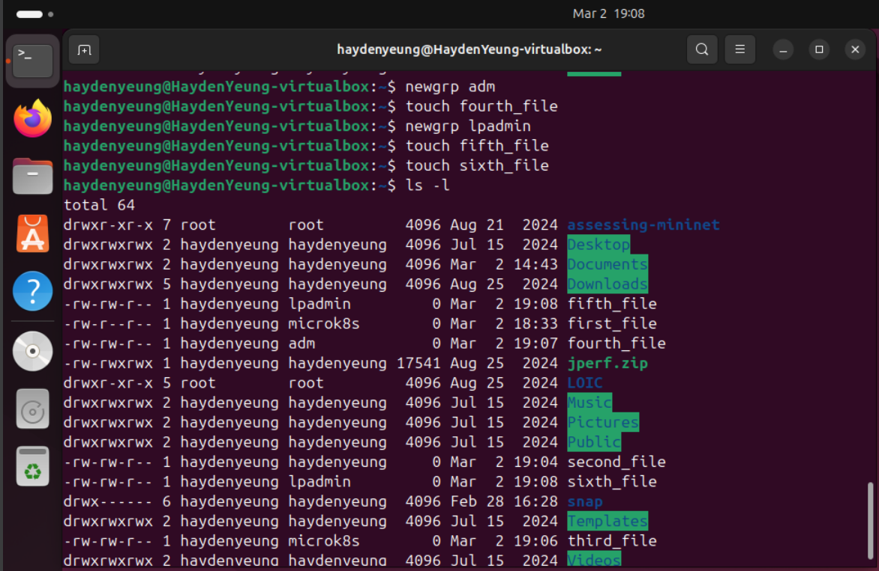

For this challenge, I proceed with the commands above and since I do not yet install wireshark into my VM, thus, I used microk8s as substituate.

Task 6 – What’s the difference?





User1 is not detected (after entered command “useradd”)

/etc/passwd:

* Purpose: Contains basic user account information such as:
  + Username.
  + Password placeholder (just to shown whether this account is associated with any password, if yes then placed as x – to be seen via /etc/shadow)
  + User ID
  + Group ID
  + User Description
  + Home Directory
  + Default Shell
* Accessibility: By everyone

/etc/shadow:

* Purpose: Store user password – both information and policies
  + Username.
  + Encrypted password (display actual password; else, \* means there is no associated password to accessing it, and ! means that account is being locked)
  + Date of the last password change (displayed under Unix Epoch format)
  + Minimum password age.
  + Maximum password age.
  + Password warning period.
  + Password inactivity period.
  + Account expiration date.
  + Reserved field.
* Access: Can only be accessed with root user password or users granted with “sudo” privileges

/home Folder:

* This directory contains the home directories of all regular users on the system.
* Each user will have a subdirectory named after their registered username.
  + These are created automatically by the time a new user is added to the system via “useradd” or “adduser” command.
* Contains user-specific files, configurations, and any related personal data.
* When a new user is created, the system:
  + Adds an entry to /etc/passwd with the user's basic information.
  + Adds an entry to /etc/shadow with the user's password and password policies.
  + Creates a home directory for the user in /home (e.g., /home/username).
  + Copies default configuration files (e.g., from /etc/skel) into the user's home directory.

Task 7 - Your Turn

For this part, I just simply followed the instructions given.

Challenge Task 3 – Working with groups

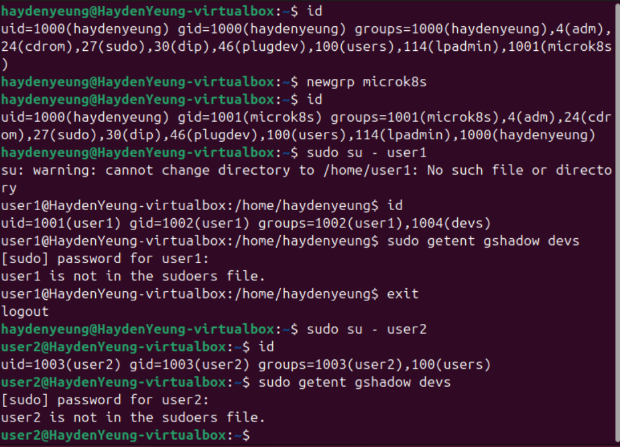

I found that since both user1 and user2 are not within the “sudo” groups thus, they are not allow to perform command “sudo getent gshadow devs”.

By further investigation with online resources and ChatGpt, I found out that user1 will expected to be able to accessed to gshadow of group devs if sudo not is not accounted by theory while user2 will not be able to as this latter is out of the said group.

Task 8 – you try

It was found that if I used “nano mytext.txt” followed by command “^T^Z” will automatically put job “nano myfile.txt” into background mode (stopped) without the need of use command “bg” on it. However, “sleep” was still able to work / running in both foreground and background.

Task 9 – Working with different signals

I found that both SIGSTOP & SIGTSTP share a similar function of stopping a program from continuing to execute. However to actually see the difference between them (in action) such as why SIGTSTP can be catched or ignored may required a more specific examples to shown its nature.

Activity 10 – There’s more than just starting and stopping…

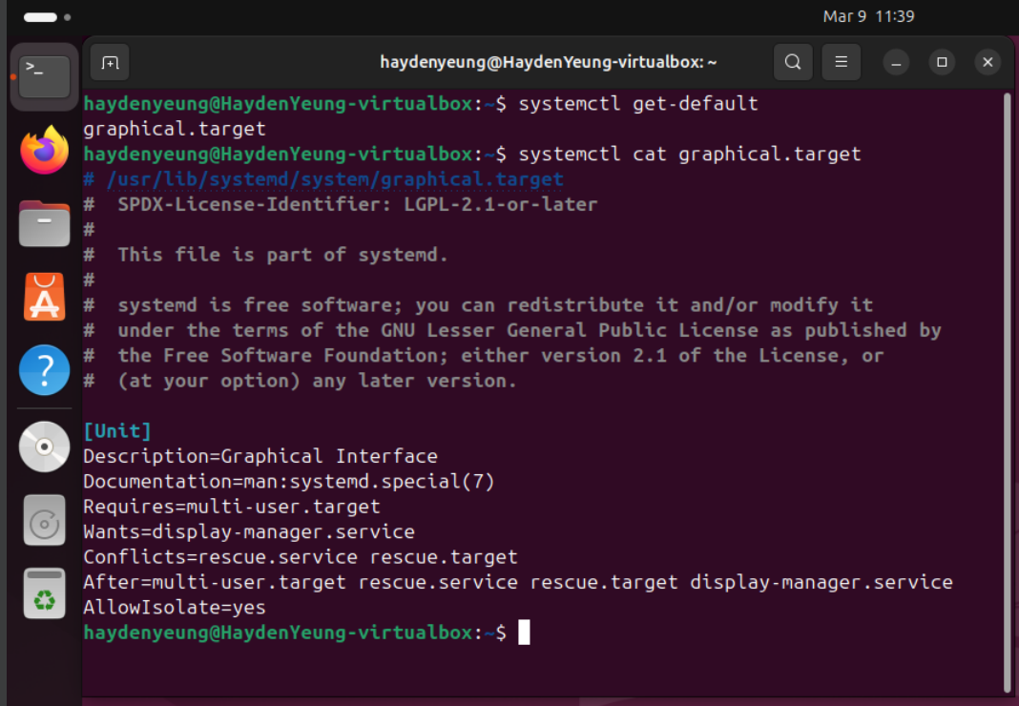

“Graphical.target” was the only file that I found through using “systemctl get-default” command. According to both ChatGPT and DeepSeek answers, this file is expected for Ubuntu.

Activity 11 – Now you try

A/ Convert 1100100111012 to hexadecimal16

1100 = c

1001 = 9

1101 = d

→ c9d16

B/ Convert 1100100111012 to octal8

110 = 6

010 = 2

011 = 3

101 = 5

→ 62358

C/ Convert 1fc516 to binary2

1 = 0001

f = 1111

c = 1100

5 = 0101

→ 0001 1111 1100 01012

D/ Convert 64328 to binary2

6 = 110

4 = 100

3 = 011

2 = 010

→ 64322

E/ Convert 8a2b16 to octal8

8 = 1000

a = 1010

2 = 0010

b = 1011

→ 1000 1010 0010 10112

→ 1 000 101 000 101 011

→ 1 0 5 0 5 3 or 1050538

III. Quiz Result

